Beijing-Xi’an-Hangzhou-Tongli-Suzhou-Shanghai
11-day/9-night China Tour hosted by Peter Tan

Itinerary: April 17-27, 2026 (attractions may be changed or cancelled by weather or Authorities)
04/17 Day 01 Friday USA FLIGHT TO BEIJING
Take an 1:00 AM international flight from Houston to Beijing. Flights from other U.S. cities are available.

04/18 Day 02 Saturday BEIJING (L-Chinese Cuisine/D-Beijing Cuisine)
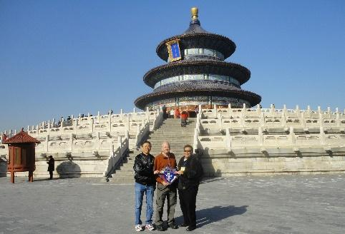
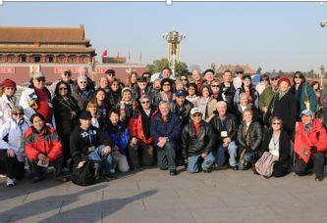
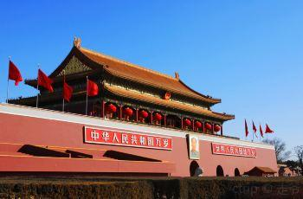
Upon arrival in Beijing, we will have lunch, then visit the Ancient Observatory (founded by Jesuits), and Temple of Heaven, lunch. After dinner, you will be transferred to your hotel.

04/19 Day 03 Sunday BEIJING (B-hotel/L-Chinese Cuisine/D-Peking Duck)
After breakfast, we will attend Sunday Mass at the Cathedral of the Immaculate Conception (Nantang), then visit Tiananmen Square, the Palace Museum (Forbidden City) and an Acrobatic Show.

04/20 Day 04 Monday BEIJING (B-hotel/L-Chinese Cuisine/D-on your own)
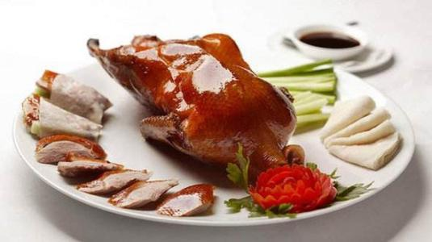
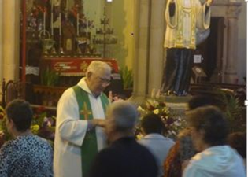
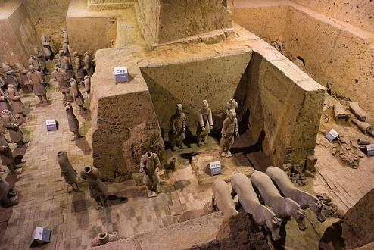
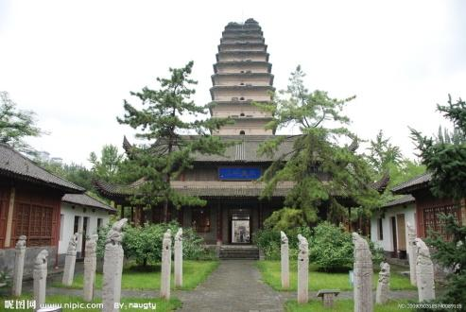
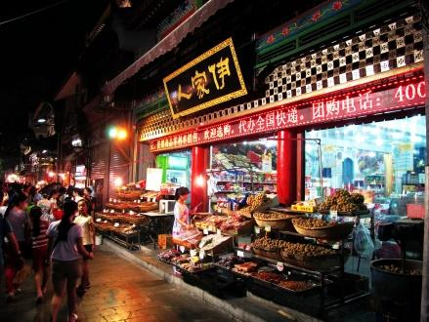
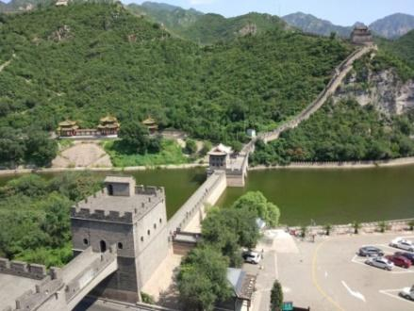
After breakfast, we will visit Mutianyu Great Wall, have lunch, then tour the Imperial Summer Palace. In the evening, we will visit the famous Wangfujing Pedestrian Street. Dinner is on your own.
04/21 Day 05 Tuesday XI’AN (B-hotel buffet / L-Self on the train / D-Dumpling banquet)
After breakfast we will depart Beijing for Xi’an on a high-speed train (2nd class coach), arriving in the afternoon. We will visit the Big Goose Pagoda and the Tang Dynasty Show & Dumpling Banquet.

04/22 Day 06 Wednesday Xi’an (B-hotel buffet / L-Shaanxi cuisine / D-on your own)
After breakfast, we will visit the Terracotta Warriors excavation site, Muslim Quarter/Gourmet Food Street and Tang Paradise Complex (Datang Furong Yuan). Dinner on your own at the Complex.

04/23 Day 07 Thursday HANGZHOU (B-hotel buffet / L-Chinese Cuisine / D-Beggar’s Chicken)
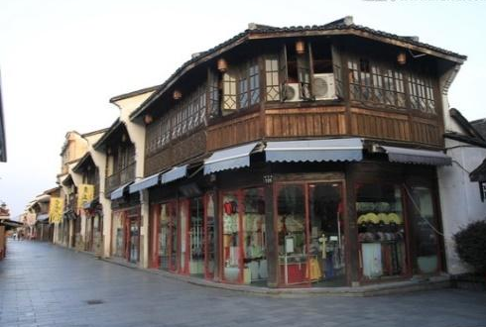
After breakfast, we leave for Xi’an Airport to catch a flight to Hangzhou. We will visit Liuhe Pagoda (Six Harmonies Pagoda), then take a boat ride on West Lake, and stroll along Hefang Ancient Street.
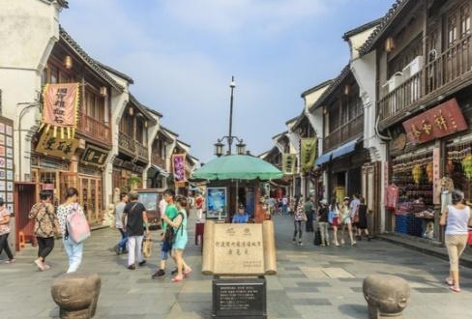


04/24 Day 08 Friday HANGZHOU - TONGLI - SUZHOU (B-hotel / L-Chinese / D-Suzhou cuisine)
After breakfast, we will tour the Meijiawu Tea Plantation, then depart for Tongli Ancient Water Town. Then we will travel to Suzhou, often referred as the Venice of the East. We will visit Han Shan temple. This evening you will enjoy the famous Suzhou feast and visit Shan Tang Walking Street after dinner.
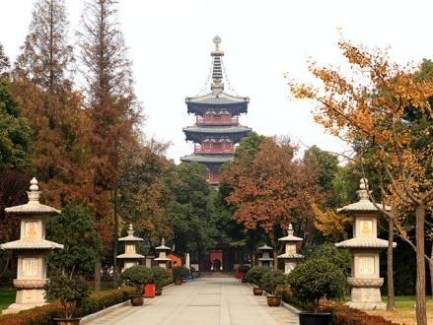
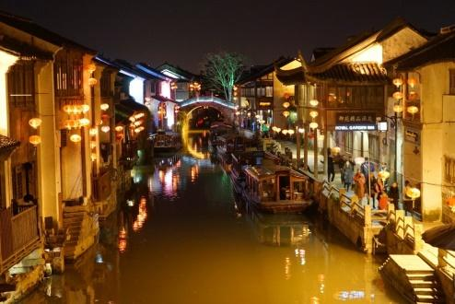
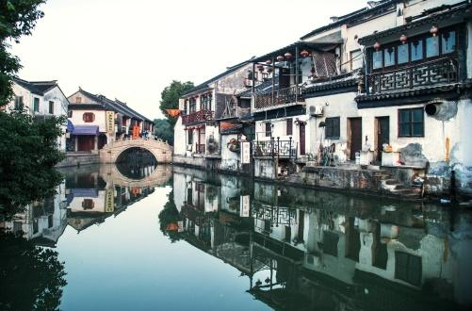

04/25 Day 09 Saturday SUZHOU – SHESHAN - SHANGHAI (B-hotel / L-Chinese / D-Shanghai)
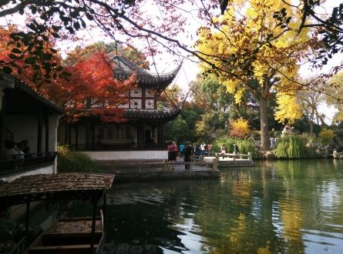
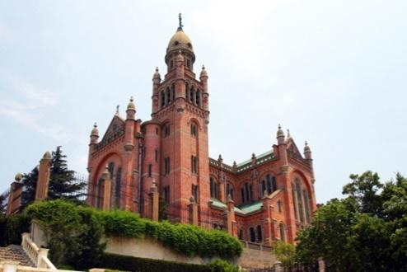
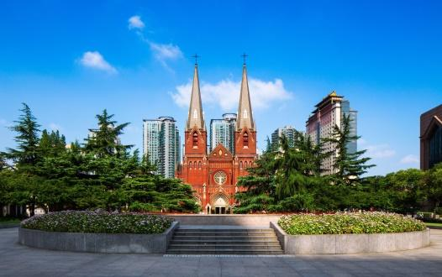
In the morning, we will tour Suzhou’s famous Lingering garden and a Suzhou’s famous silk factory. After lunch, we will make a pilgrimage to Our Lady of Sheshan Basilica, then depart for Shanghai. We will attend the 6 PM Mass at the Church of Xujiahui, also known as St. Ignatius Cathedral.
04/26 Day 10 Sunday SHANGHAI (B-hotel buffet / L-on your own / D-Old Shanghai cuisine)
After breakfast, we will tour Shanghai’s famous Bund and Waterfront. Then we will walk to Nanjing Pedestrian Street where you will find your own lunch. In the afternoon, we will go shopping at the A.P. /Yada-Shenghui Tourism Shopping Plaza and the enchanting Yu Yuan Shopping Complex. Tonight, we will experience an Old Shanghai cuisine for dinner.
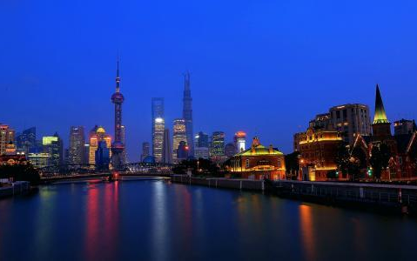
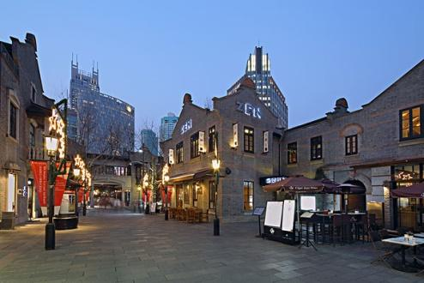

04/27 Day 11 Monday SHANGHAI (B-hotel buffet)
After breakfast, relax in the hotel or go out on your own. (Some of you will have to catch an earlier flight). In the afternoon, you will be transferred to Shanghai Pudong Airport for your flight home.

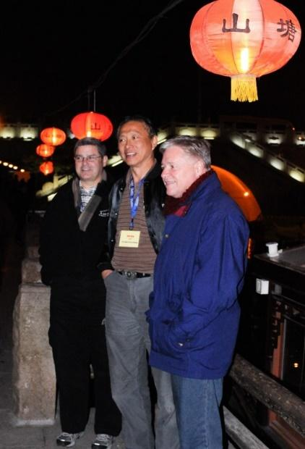
Services Included:

1. International and domestic economy air tickets in the itinerary.
2. 2nd class high speed train ticket in the itinerary.
3. Hotels and meals in each city as shown in the itinerary.
4. Coach Service.
5. Entrance fees in the itinerary.
6. English-speaking tour guides.

Services NOT Included:

1. Personal Expenditures.
2. Chinese visa for U.S. passports ($250/ten years).
3. Tips USD10 per day for tour guide and coach driver.
4. Suggested $20+/pax donation/tithe to cathedrals after Masses.
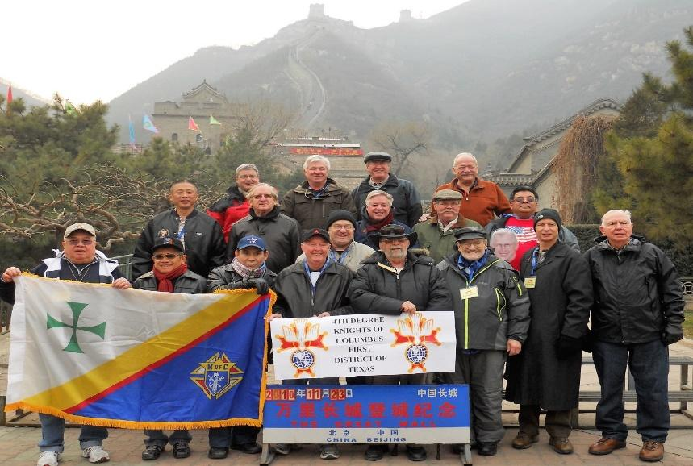
Application Form - $2,975 per person (Double Occupancy)
$480 single room supplement
Name: ………………………………………… Spouse Name: ………………………………
Address: …………………………………………………………………………………………
…………………………………………………………………………………………
Phone: ………………… Cellular: ………………… Email: …………………………………
Passport No: …………………… Issue Date: ………………… Exp Date: …………………
Passport No: …………………… Issue Date: ………………… Exp Date: …………………
Credit Card- MC/VI/DS (add 3.5%): …………………… Exp: ……… Check #: ……………
Emergency Notification
Name: …………………………… Phone: ………………… Relationship: …………………
Travelers Insurance: Must Special Request (Handicap/Dietary Meals, Etc):
……………………………………………………………………………………………………

By 01/30/2026: Down payment ($1,000/person deposit) w/Registration & copy of Passport.
There is no more cancellation. Purchase Travelers insurance to avoid any loss.

By 03/01/2026: Final Balance Payment.

A copy of passport must accompany 1st deposit payment
Make payment checks to: Apollo Travel & Tours
By participating in this tour, you tacitly agree to indemnify Peter Tan, the US-China Catholic Association (USCCA), and James Khoh/Apollo Travel from any legal action.

For more Information: Peter Tan Tel: 832-470-2723 email: petertan@juno.com

Apollo Travel & Tours - Tour & Ticketing Designated Agent email: james.khoh@gmail.com
James Khoh Tel: 713-490-7888 Cell: 281-851-4888
4103 Amersham Way, Sugar Land, Texas 77479

Itinerary including flights can be adjusted. Contact James Khoh

